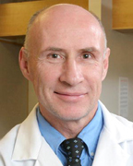

[**Shalnov, Anatoly, MD**](http://www.challiance.org/cha/find-a-doctor/shalnov_anatoly_md_402.aspx)

* **Specialties**

Orthopaedics (Bone, Muscles & Joints)  
Physiatry

**Languages**

English  
Russian

**Practice Locations**

CHA Cambridge Hospital Campus  
CHA Malden Bone & Joint Center

### Specialty Referrals

**For Patients:** If you think you need specialty care for a complex health need, [**contact your site directly**](http://www.challiance.org/location/primary-care-locations.aspx) and talk to your primary care team. They can help you find a great doctor at CHA or a CHA partner hospital (“in network”) like Beth Israel Deaconess Medical Center (BIDMC).

For more information about getting a specialty referral at CHA, please review our online

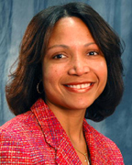

## [Noel, Magaly, MD, MPH](http://www.challiance.org/cha/find-a-doctor/noel_magaly_md_mph_401.aspx)

### Specialties

Orthopaedics (Bone, Muscles & Joints)  
Physiatry

### Languages

English  
French  
Haitian Creole

### Practice Locations

CHA Assembly Square Care Center  
CHA Bone & Joint Center, Malden

### Specialty Referrals

**For Patients:** If you think you need specialty care for a complex health need, [**contact your site directly**](http://www.challiance.org/location/primary-care-locations.aspx) and talk to your primary care team. They can help you find a great doctor at CHA or a CHA partner hospital (“in network”) like Beth Israel Deaconess Medical Center (BIDMC).

For more information about getting a specialty referral at CHA, please review our online



## [Freedman, Jason, MD](http://www.challiance.org/cha/find-a-doctor/freedman_jason_md_394.aspx)

### Specialties

Orthopaedics (Bone, Muscles & Joints)  
Sports Medicine

### Languages

English

### Practice Locations

CHA Assembly Square Care Center  
CHA Cambridge Hospital

### Specialty Referrals

**For Patients:** If you think you need specialty care for a complex health need, [**contact your site directly**](http://www.challiance.org/location/primary-care-locations.aspx) and talk to your primary care team. They can help you find a great doctor at CHA or a CHA partner hospital (“in network”) like Beth Israel Deaconess Medical Center (BIDMC).

For more information about getting a specialty referral at CHA, please review our online

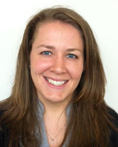

## [Winslett, Rebecca, PA-C](http://www.challiance.org/cha/find-a-doctor/winslett_rebecca_pac_407.aspx)

### Specialties

General Orthopaedics  
Orthopaedics (Bone, Muscles & Joints)  
Sports Medicine

### Languages

English

### Practice Locations

CHA Assembly Square Care Center  
CHA Cambridge Hospital

### Specialty Referrals

**For Patients:** If you think you need specialty care for a complex health need, [**contact your site directly**](http://www.challiance.org/location/primary-care-locations.aspx) and talk to your primary care team. They can help you find a great doctor at CHA or a CHA partner hospital (“in network”) like Beth Israel Deaconess Medical Center (BIDMC).

For more information about getting a specialty referral at CHA, please review our online

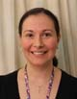

## [Braza, Julia, MD, MS](http://www.challiance.org/cha/find-a-doctor/braza_julia_md_ms_802.aspx)

### Specialties

Pathology

### Languages

English

### Practice Locations

CHA Cambridge Hospital Campus

### Specialty Referrals

**For Patients:** If you think you need specialty care for a complex health need, [**contact your site directly**](http://www.challiance.org/location/primary-care-locations.aspx) and talk to your primary care team. They can help you find a great doctor at CHA or a CHA partner hospital (“in network”) like Beth Israel Deaconess Medical Center (BIDMC).

For more information about getting a specialty referral at CHA, please review our online

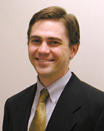

## [Elvin, David, MD](http://www.challiance.org/cha/find-a-doctor/elvin_david_md_14.aspx)

### Specialties

Internal Medicine  
Pediatrics  
Primary Care

### Languages

English  
Spanish

**New Patients**

Call us at **(617) 665-1305** or use our

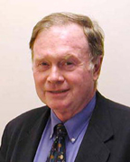

[**Nolan, James A., MD**](http://www.challiance.org/cha/find-a-doctor/nolan_james_a_md_8.aspx)

* **Specialties**

Internal Medicine  
Pediatrics  
Primary Care

**Languages**

English  
Portuguese

**Practice Locations**

CHA Inman Square Care Center  
CHA Porter Square Care Center

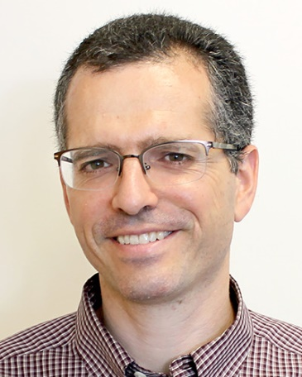

## [Sawady, Joel, MD](http://www.challiance.org/cha/find-a-doctor/sawady_joel_md_132.aspx)

### Specialties

Internal Medicine  
Pediatrics  
Primary Care

### Languages

English  
Haitian Creole  
Hebrew  
Spanish

### Practice Locations

CHA Inman Square Care Center  
CHA Porter Square Care Center

### New Patients

Call us at **(617) 665-1305** or use our



## [Renner, Erich, MD](http://www.challiance.org/cha/find-a-doctor/renner_erich_md_920.aspx)

### Specialties

Newborn Nursery Doctor

### Languages

English  
German

### Practice Locations

CHA Cambridge Hospital Campus

### Specialty Referrals

**For Patients:** If you think you need specialty care for a complex health need, [**contact your site directly**](http://www.challiance.org/location/primary-care-locations.aspx) and talk to your primary care team. They can help you find a great doctor at CHA or a CHA partner hospital (“in network”) like Beth Israel Deaconess Medical Center (BIDMC).

For more information about getting a specialty referral at CHA, please review our online



## [Burch, J. Lyra, MD](http://www.challiance.org/cha/find-a-doctor/burch_j_lyra_md_806.aspx)

### Specialties

Newborn Nursery Doctor

### Languages

English  
Spanish

### Practice Locations

CHA Cambridge Hospital Campus

### Specialty Referrals

**For Patients:** If you think you need specialty care for a complex health need, [**contact your site directly**](http://www.challiance.org/location/primary-care-locations.aspx) and talk to your primary care team. They can help you find a great doctor at CHA or a CHA partner hospital (“in network”) like Beth Israel Deaconess Medical Center (BIDMC).

For more information about getting a specialty referral at CHA, please review our online



## [Mitchell, Deborah, MD](http://www.challiance.org/cha/find-a-doctor/mitchell_deborah_md_947.aspx)

### Specialties

Pediatric Endocrinology

### Languages

English

### Practice Locations

CHA Cambridge Pediatrics

### Specialty Referrals

**For Patients:** If you think you need specialty care for a complex health need, [**contact your site directly**](http://www.challiance.org/location/primary-care-locations.aspx) and talk to your primary care team. They can help you find a great doctor at CHA or a CHA partner hospital (“in network”) like Beth Israel Deaconess Medical Center (BIDMC).

For more information about getting a specialty referral at CHA, please review our online

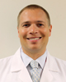

[**Berg, Erik, MD**](http://www.challiance.org/cha/find-a-doctor/berg_erik_md_701.aspx)

* **Specialties**

Otolaryngology (ENT)  
Surgery

**Languages**

English

**Practice Locations**

CHA Cambridge Hospital Campus  
CHA Somerville Hospital Campus  
CHA Everett Hospital

**Specialty Referrals**

**For Patients:** If you think you need specialty care for a complex health need, [**contact your site directly**](http://www.challiance.org/location/primary-care-locations.aspx) and talk to your primary care team. They can help you find a great doctor at CHA or a CHA partner hospital (“in network”) like Beth Israel Deaconess Medical Center (BIDMC).

For more information about getting a specialty referral at CHA, please review our online

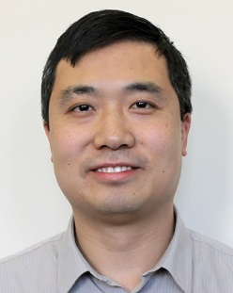

[**Shao, Weiru, MD**](http://www.challiance.org/cha/find-a-doctor/shao_weiru_md_1016.aspx)

* **Specialties**

Otolaryngology (ENT)  
Surgery

**Languages**

English

**Practice Locations**

CHA Cambridge Hospital Campus  
CHA Everett Hospital

**Specialty Referrals**

**For Patients:** If you think you need specialty care for a complex health need, [**contact your site directly**](http://www.challiance.org/location/primary-care-locations.aspx) and talk to your primary care team. They can help you find a great doctor at CHA or a CHA partner hospital (“in network”) like Beth Israel Deaconess Medical Center (BIDMC).

For more information about getting a specialty referral at CHA, please review our online

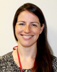

[**Gross, Joanna, PA-C**](http://www.challiance.org/cha/find-a-doctor/gross_joanna_pac_644.aspx)

* **Specialties**

Otolaryngology (ENT)  
Surgery

**Languages**

English

**Practice Locations**

CHA Cambridge Hospital Campus  
CHA Everett Hospital

**Specialty Referrals**

**For Patients:** If you think you need specialty care for a complex health need, [**contact your site directly**](http://www.challiance.org/location/primary-care-locations.aspx) and talk to your primary care team. They can help you find a great doctor at CHA or a CHA partner hospital (“in network”) like Beth Israel Deaconess Medical Center (BIDMC).

For more information about getting a specialty referral at CHA, please review our online

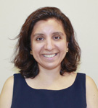

[**Khalid, Ayesha, MD, FACS**](http://www.challiance.org/cha/find-a-doctor/khalid_ayesha_md_facs_899.aspx)

* **Specialties**

Otolaryngology (ENT)  
Surgery

**Languages**

English  
French  
Urdu

**Practice Locations**

CHA Cambridge Hospital Campus  
CHA Everett Hospital

**Specialty Referrals**

**For Patients:** If you think you need specialty care for a complex health need, [**contact your site directly**](http://www.challiance.org/location/primary-care-locations.aspx) and talk to your primary care team. They can help you find a great doctor at CHA or a CHA partner hospital (“in network”) like Beth Israel Deaconess Medical Center (BIDMC).

For more information about getting a specialty referral at CHA, please review our online

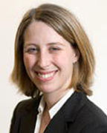

[**Halperin, Terri, MD**](http://www.challiance.org/cha/find-a-doctor/halperin_terri_md_595.aspx)

* **Specialties**

Plastic Surgery  
Surgery

**Languages**

English

**Practice Locations**

Cambridge Breast Center  
CHA Cambridge Hospital Campus  
Other

**Specialty Referrals**

**For Patients:** If you think you need specialty care for a complex health need, [**contact your site directly**](http://www.challiance.org/location/primary-care-locations.aspx) and talk to your primary care team. They can help you find a great doctor at CHA or a CHA partner hospital (“in network”) like Beth Israel Deaconess Medical Center (BIDMC).

For more information about getting a specialty referral at CHA, please review our online

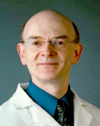

[**Heffernan, Paul M., DPM**](http://www.challiance.org/cha/find-a-doctor/heffernan_paul_m_dpm_602.aspx)

* **Specialties**

Podiatric Surgery  
Podiatry (Foot Care)  
Surgery

**Languages**

English

**Practice Locations**

CHA Cambridge Hospital Campus  
CHA East Cambridge Care Center  
CHA Somerville Hospital Campus

**Specialty Referrals**

**For Patients:** If you think you need specialty care for a complex health need, [**contact your site directly**](http://www.challiance.org/location/primary-care-locations.aspx) and talk to your primary care team. They can help you find a great doctor at CHA or a CHA partner hospital (“in network”) like Beth Israel Deaconess Medical Center (BIDMC).

For more information about getting a specialty referral at CHA, please review our online

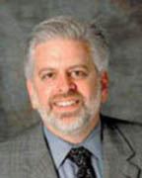

[**Landsman, Adam, DPM, PhD, FACFAS**](http://www.challiance.org/cha/find-a-doctor/landsman_adam_dpm_phd_facfas_596.aspx)

* **Specialties**

Podiatric Surgery  
Podiatry (Foot Care)  
Surgery

**Languages**

English

**Practice Locations**

CHA Cambridge Hospital Campus  
CHA Everett Hospital

**Specialty Referrals**

**For Patients:** If you think you need specialty care for a complex health need, [**contact your site directly**](http://www.challiance.org/location/primary-care-locations.aspx) and talk to your primary care team. They can help you find a great doctor at CHA or a CHA partner hospital (“in network”) like Beth Israel Deaconess Medical Center (BIDMC).

For more information about getting a specialty referral at CHA, please review our online

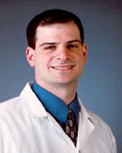

[**Schneider, Harry P., DPM, FACFAS**](http://www.challiance.org/cha/find-a-doctor/schneider_harry_p_dpm_facfas_597.aspx)

* **Specialties**

Podiatric Surgery  
Podiatry (Foot Care)  
Surgery

**Languages**

English

**Practice Locations**

CHA Cambridge Hospital Campus  
CHA Everett Hospital

### Specialty Referrals

**For Patients:** If you think you need specialty care for a complex health need, [**contact your site directly**](http://www.challiance.org/location/primary-care-locations.aspx) and talk to your primary care team. They can help you find a great doctor at CHA or a CHA partner hospital (“in network”) like Beth Israel Deaconess Medical Center (BIDMC).

For more information about getting a specialty referral at CHA, please review our online

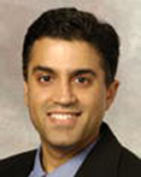

## [Sheth, Ketan, MD, FACS](http://www.challiance.org/cha/find-a-doctor/sheth_ketan_md_facs_583.aspx)

### Specialties

General Surgery  
Hepatobiliary Surgery  
Minimally Invasive Surgery  
Surgery  
Surgical Oncology

### Languages

English

### Practice Locations

CHA Cambridge Hospital Campus  
CHA Somerville Hospital Campus

### Specialty Referrals

**For Patients:** If you think you need specialty care for a complex health need, [**contact your site directly**](http://www.challiance.org/location/primary-care-locations.aspx) and talk to your primary care team. They can help you find a great doctor at CHA or a CHA partner hospital (“in network”) like Beth Israel Deaconess Medical Center (BIDMC).

For more information about getting a specialty referral at CHA, please review our online